AKS Dev Architecture:

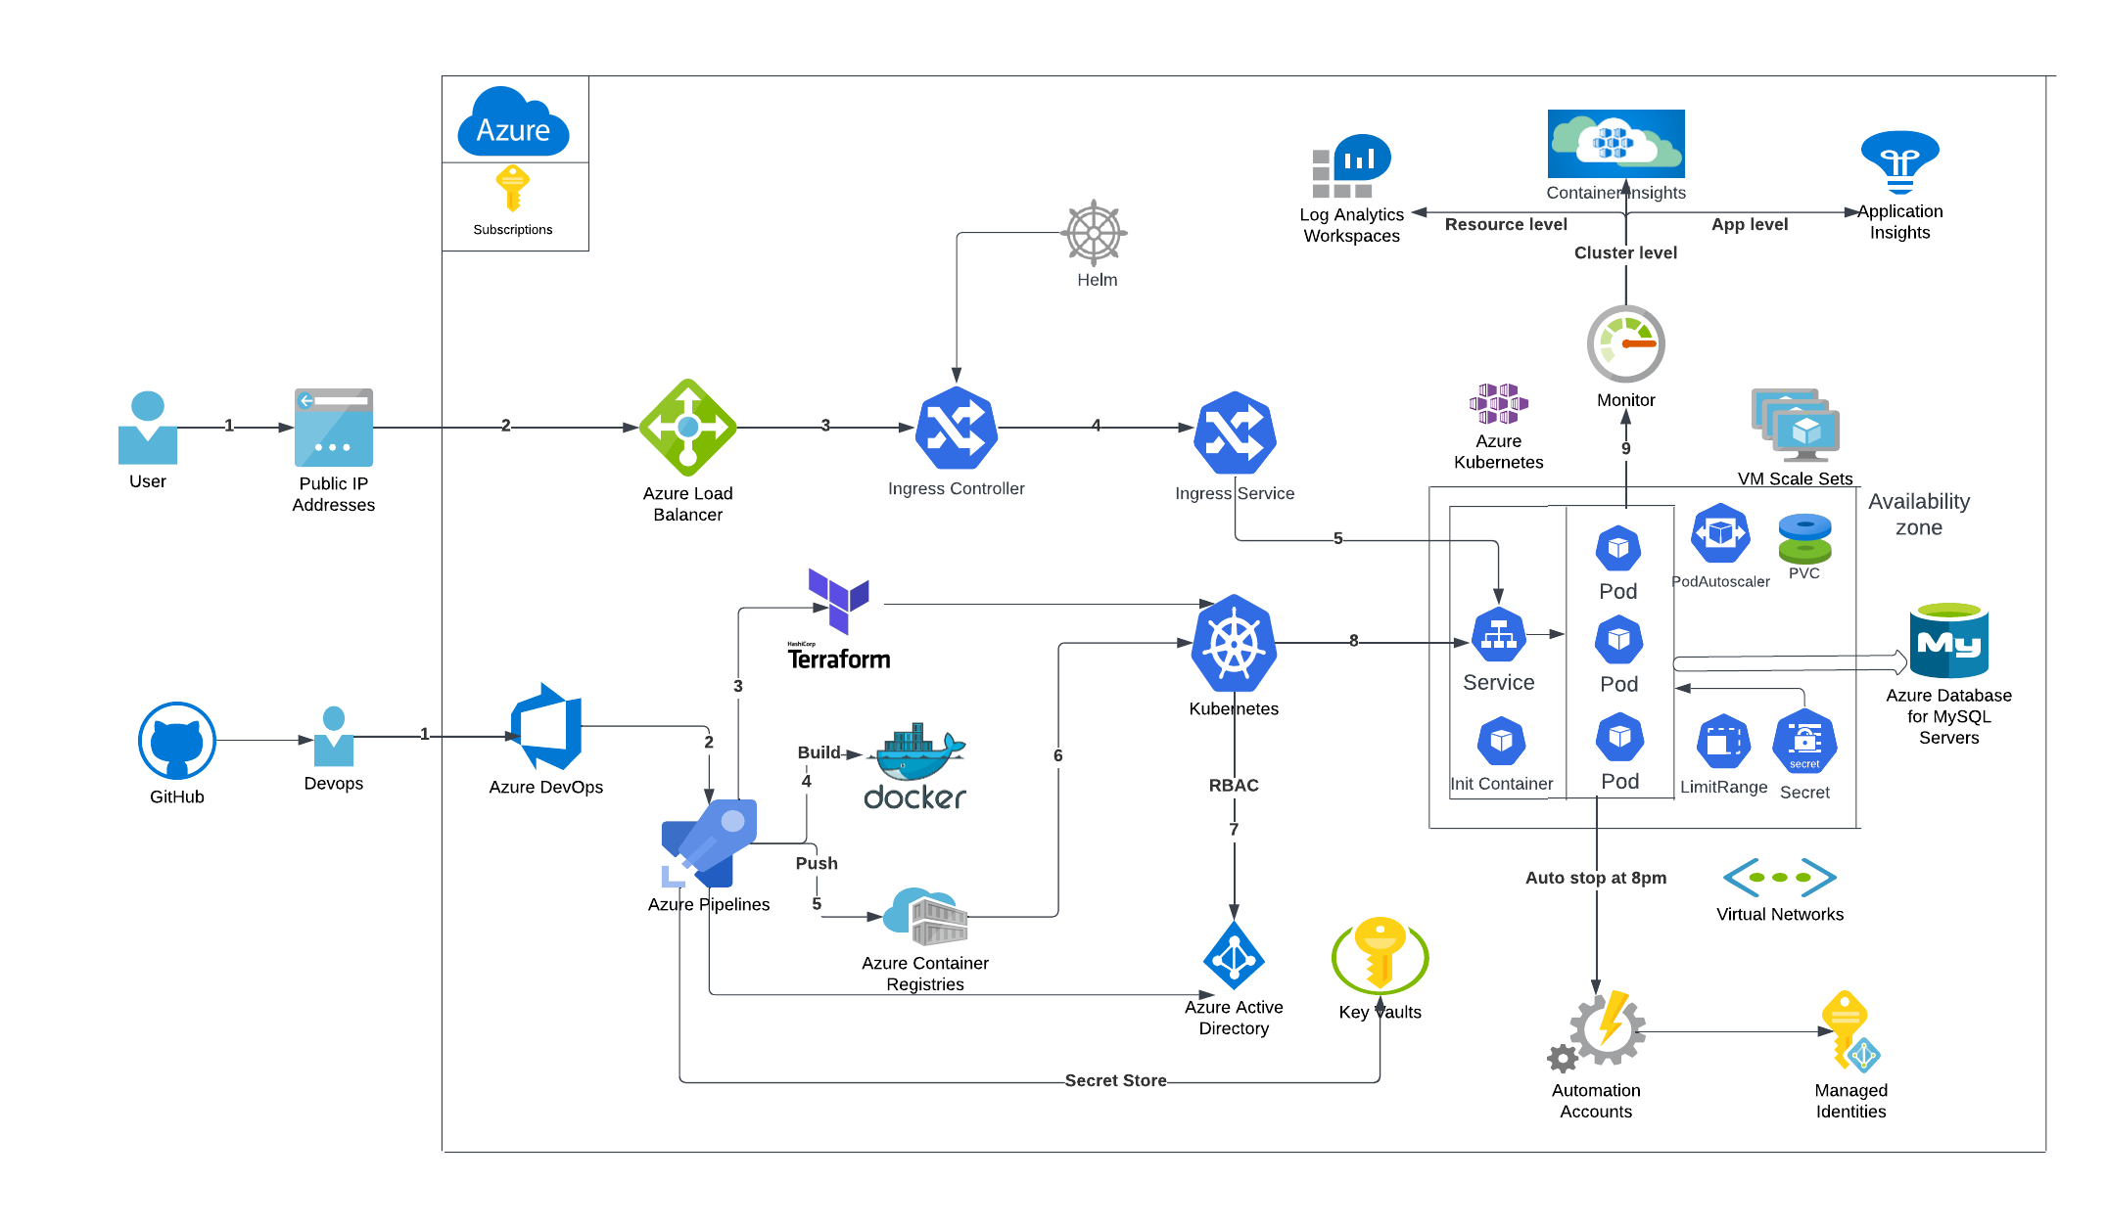

Data Flows:

1. A Devops clone the Github Repository to Azure Devops Repos.
2. Building a CICD Pipeline to Automate the Terraform Deployment to Azure.
3. Service connection in Azure Devops has been used as an Authentication token between Azure Devops and Azure.  
    Validate the resources once its deployed in Azure.
4. Building a CICD Pipeline to Automate the Application Deployment in AKS.
5. Creating a Service Connection to Authenticate AKS and CICD Pipeline after Authenticating to AAD.
6. Build stage to Build the Docker File and Push the Image to Azure Container Registry.
7. Deploy stage will leverage ACR Image pull secret to deploy the ACR Repo to AKS Cluster.
8. Azure MySQL Database is used as a Persistent backend store for the AKS Pods.
9. Pipeline secrets are retrieved from Azure Key vault during deployment.

Once the Deployment is Completed. The Application would be accessible with the External IP.

AKS cluster monitoring is setup at Resource level, Cluster level and Application level.

1. Azure Automation Account has been setup to stop the AKS Dev Cluster at 8pm and start at 8am.